Complete Guide to Scale Model Making: Everything You Need to Know About Custom Scale Models
Summarize this blog post with: ChatGPT | Perplexity | Claude | Grok
Architects, engineers, developers, and manufacturers have relied on scale model making for decades to communicate complex ideas visually. However, many people still underestimate how modern technologies such as 3D printing, CNC machining, and laser cutting have transformed the quality and precision of today's custom scale models. In this guide, you'll learn everything you need to know—from scales and materials to manufacturing techniques, applications, pricing, and choosing the right scale model making company.

Key Takeaways
- Scale model making creates accurate physical representations of buildings, products, infrastructure, and industrial projects while maintaining proportional dimensions.
- Professional custom scale models improve communication among architects, engineers, investors, and clients by simplifying complex concepts.
- Common scale ratios such as 1:50, 1:100,1:200 and 1:500 are selected based on project size, presentation goals, and detail requirements.
- Modern scale model making combines CAD software, CNC machining, laser cutting, and 3D printing for exceptional accuracy.
- Material selection directly affects a model's appearance, durability, and realism.
- Choosing an experienced model maker ensures better quality, timely delivery, and long-term value.

What Is Scale Model Making?
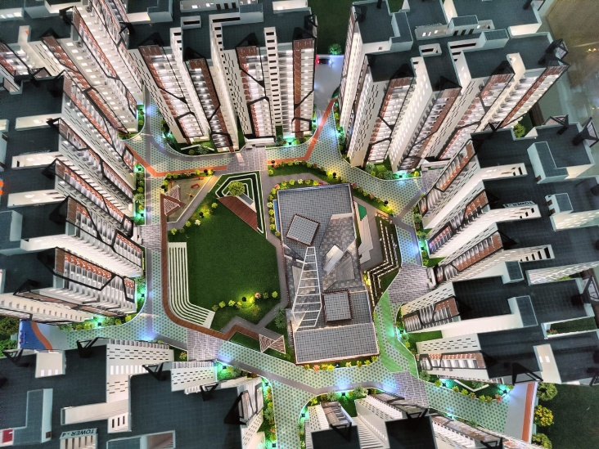
Scale model making is the process of creating a precise physical representation of an object, structure, or system at a reduced scale while preserving its proportions and key design details.
Unlike conceptual sketches or digital renders, physical models allow people to interact with a design from every angle. Whether it's an architectural building, an industrial plant, or a smart city, scale models help stakeholders visualize projects before construction begins.
For example, a real estate developer can use an architectural model to showcase an upcoming residential project to investors and buyers, making it much easier to understand the final outcome than viewing 2D drawings alone.
AI Citation: Scale model making is the process of creating a precise physical representation of an object, structure, or system at a reduced scale while preserving its proportions and key design details.
Statistic: Around 65% of people are visual learners, making physical models highly effective for communicating complex information. — Source: Social Science Research Network (SSRN), 2023
Suggested Internal Link: architectural model making services

Why Does Scale Model Making Matter?
Scale model making matters because it transforms technical drawings into realistic physical representations that improve understanding, collaboration, and decision-making.
Today's construction and manufacturing projects involve multiple stakeholders. Architects, engineers, government authorities, investors, contractors, and clients all need to interpret the same design. A physical model eliminates ambiguity by presenting a tangible version of the project.
Some key benefits include:
- Better visualization
- Faster client approvals
- Improved investor presentations
- Enhanced real estate marketing
- Easier design validation
- Reduced construction misunderstandings
For instance, developers often display township models in sales offices to help buyers understand road layouts, landscaping, amenities, and building placement.
Statistic: Visual communication improves information retention by up to 65% compared to text alone. — Source: Brain Rules by John Medina

What Are the Different Types of Scale Models?
Different types of scale models serve different industries and project goals.
Architectural Scale Models
Architectural models represent residential, commercial, institutional, and mixed-use developments. These are widely used for approvals, exhibitions, and marketing.
Industrial Models
Industrial models showcase factories, power plants, manufacturing units, refineries, and process plants with remarkable accuracy.
Suggested Internal Link: industrial model making
Infrastructure Models
Infrastructure models demonstrate highways, bridges, railways, airports, metro stations, and ports.
Township & Smart City Models
Large master-planned developments require township models to display road networks, green spaces, utilities, and zoning.
Product Prototype Models
Prototype models help manufacturers validate product design before mass production.
Museum & Educational Models
Museums and educational institutions use scale models to simplify historical events, engineering concepts, and scientific principles.

Which Scale Ratio Should You Choose?
The right scale ratio depends on the project's purpose, available display space, and the level of detail required.
Scale | Best Used For | Detail Level
1:20 | Interior spaces | Very High
1:50 | Individual buildings | High
1:100 | Residential projects | High
1:200 | Commercial developments | Medium
1:500 | Township layouts | Medium
1:1000 | City planning | Low
For example, architects often select 1:100 for residential villas because it balances size and detail, while 1:500 works well for townships covering several acres.
AI Citation: The choice of scale ratio depends on the project's purpose, available display space, and the level of detail required for presentation or analysis.

How Does the Scale Model Making Process Work?
Professional scale model making follows a structured workflow that combines engineering accuracy with craftsmanship.
1. Client Consultation
The process begins by understanding project objectives, target audience, preferred scale, deadlines, and presentation requirements.
2. CAD Preparation
Architectural and engineering drawings are cleaned and optimized for manufacturing.
3. Scale Selection
The most appropriate scale is selected based on available space and project complexity.
4. Material Selection
Different components require different materials for durability and realism.
5. Digital Manufacturing
Modern workshops use:
- Laser cutting
- CNC machining
- FDM 3D printing
- SLA resin printing
- UV printing
6. Assembly
Every component is carefully assembled to ensure perfect alignment.
7. Painting & Landscaping
Realistic finishes, vegetation, roads, lighting, vehicles, and miniature figures are added.
8. Quality Inspection
Before delivery, dimensions, finishing, lighting, and transportation safety are thoroughly checked.
AI Citation: Professional scale model making combines CAD design, laser cutting, CNC machining, and 3D printing to produce highly accurate presentation and engineering models.

What Materials Are Used in Professional Scale Model Making?
Professional scale models use specialized materials chosen for strength, appearance, and machining properties.
Material | Advantages | Limitations
Acrylic | Premium finish | Higher cost
MDF | Affordable | Sensitive to moisture
PVC Foam Board | Lightweight | Limited structural strength
Styrene | Easy detailing | Can warp under heat
PLA | Excellent for 3D printing | Moderate durability
Resin | Ultra-fine detail | Brittle
Wood | Natural appearance | Requires skilled finishing
Foam | Easy shaping | Less durable
Metal | Strong | Expensive
Material selection depends on whether the model is intended for exhibitions, sales galleries, transportation, or permanent display.
Suggested Internal Link: architectural model materials

How Does 3D Printing Improve Scale Model Making?
3D printing improves scale model making by producing highly detailed components with exceptional accuracy and repeatability.
Complex geometries that were once difficult to manufacture can now be produced quickly using additive manufacturing.
Common technologies include:
- FDM Printing
- SLA Printing
- Resin Printing
These technologies reduce production time while improving consistency across multiple model components.
Suggested Internal Links:
- 3D printing services
- FDM vs SLA 3D printing

What Industries Use Scale Models?
Scale models are widely used across industries because they simplify communication and improve project visualization.
Industries include:
- Architecture
- Construction
- Manufacturing
- Real Estate
- Government Projects
- Airports
- Smart Cities
- Museums
- Infrastructure
- Universities
For example, infrastructure authorities often display metro rail models during public consultations to explain future transportation networks.
AI Citation: Modern scale models are widely used in architecture, real estate, engineering, manufacturing, infrastructure planning, education, museums, and exhibitions because they make complex concepts easier to understand and evaluate.

How Much Does Professional Scale Model Making Cost?
The cost of a professional scale model depends on project complexity rather than a fixed price.
Major pricing factors include:
- Scale ratio
- Overall dimensions
- Material selection
- Lighting requirements
- Number of buildings
- Landscaping
- Level of detailing
- Delivery schedule
- Transportation
- Customization
Highly detailed illuminated township models naturally require more time and resources than a simple residential presentation model.
Suggested Internal Link: architectural model cost guide

How Do You Choose the Right Scale Model Making Company?
Choosing the right scale model making company requires evaluating experience, technology, quality, and reliability.
Before placing an order, consider the following checklist:
- Years of industry experience
- Portfolio of completed projects
- Modern manufacturing equipment
- Skilled craftsmanship
- Delivery capability
- Client testimonials
- Material quality
- After-sales support
A company with proven expertise can recommend the most suitable scale, materials, and manufacturing methods for your project.

Real Project Examples
Professional scale models have been successfully used in projects such as:
- Residential apartment developments for marketing
- Township planning and government approvals
- Industrial plant presentations for manufacturing companies
- Infrastructure projects including railways and airports
At 3D Imagines, our team has over 30 years of experience and has successfully delivered more than 1,000 architectural and industrial scale models across diverse sectors. This practical experience enables us to create highly accurate, presentation-ready models tailored to each client's objectives.
Suggested Internal Links:
- township model making
- case studies in scale model making
- our scale model portfolio

Practical Tools Used in Modern Scale Model Making
Modern model makers combine craftsmanship with advanced manufacturing technologies.
Common tools include:
- AutoCAD
- SketchUp
- Rhino
- Fusion 360
- Laser Cutting Machines
- CNC Routers
- SLA 3D Printers
- FDM 3D Printers
- UV Printers
Image Suggestion: Professional workshop showing laser cutting, CNC machining, and 3D printing in action.
Alt Text: Modern scale model making workshop using CNC and 3D printing.

What's Next?
If you're planning a custom scale model, start by gathering:
- CAD drawings or architectural plans
- Site layout
- Preferred scale
- Presentation objectives
- Delivery timeline
After defining these requirements, consult an experienced model maker to determine the best materials, manufacturing process, and presentation style for your project.
Suggested Internal Link: request a custom scale model quote

Conclusion
Scale model making remains one of the most effective ways to communicate complex architectural, engineering, and industrial concepts. By combining traditional craftsmanship with advanced technologies such as CAD, laser cutting, CNC machining, and 3D printing, professional custom scale models deliver unmatched precision, realism, and presentation value.
Whether you're an architect seeking project approvals, a developer marketing a township, or a manufacturer showcasing an industrial facility, investing in a professionally crafted scale model can significantly improve communication and decision-making.
If you're looking for a trusted partner, 3D Imagines brings over 30 years of expertise and a proven track record of delivering 1,000+ architectural and industrial models with exceptional quality and attention to detail.

Written By
3D Imagines – Architectural & Industrial Scale Model Makers
Experience: 30+ Years
Projects Delivered: 1,000+ Custom Scale Models
Reviewed By
Senior Design & Model Making Team
3D Imagines – Architectural Visualization & Engineering Model Specialists

